BT542 Midterm
Berat Kaan Çelen

Football Manager Database Design

Business Rules
Topic is about football manager video game database design.
Original video game contains a lot of data,entities and attributes thus i crop a part of game and made design of it.
Following items show concepts, entities and relations, there is 4 main entity which is Person, Team, Stadium and Position
- Person (name, surname, birthday, nationality)
  - Chairman (wealth)
  - Member (contract start date, contract end date, wage)
    - Coach (technical coach skills, mental coach skills)
    - Player (height, weight, mental skills, physical skills, morale, condition)
      - Goolkeeper (goolkeeping skills)
      - Footballer (technical skills)
- Team (label, name, foundation year, color code 1, color code 2)
- Stadium (name, address, capacity, opening date)
- Position (label)
- Person nationality should be 3-letter country code
- Chairman wealth must be between [1-20]
- Member wage accepted as yearly wage and dollar as currency
- Player moral must be between [1-5]
- Player condition must be between [1-100]
- A Player must have 1 or more position
- Position labels must be followings
  - GK,DL,DC,DR,DML,DMC,DMR,ML,MC,MR,AML,AMC,AMR,FL,FC,FR,ST
- Team color code 1 and color code 2 must be 6-digit hexadecimal color code but should be keeping in database as text
- All skill attributes must be between [1-20] which is followings
- Technical coach skills contains
  - Attacking
  - Defending
  - Fitness
  - Goolkeepers
  - Man management
- Mental coach skills contains
  - Judging player ability
  - Judging player potantial
  - Level of discipline
  - Motivating
  - Tactical knowledge
- Goolkeeping skills contains
  - Aerial ability
  - Command of area
  - Handling
  - One on ones
  - Reflexes
- Technical skills contains
  - First touch
  - Heading
  - Marking
  - Passing
  - Technique
- Mental skills contains
  - Bravery
  - Creativity
  - Positioning
  - Teamwork
  - Work rate
- Physical skills contains
  - Jumping
  - Natural fitness
  - Pace
  - Stamina
  - Strength
- A team must have 1 chairman, but chairman can be unoccupied
- A team must have 1 manager type of coach, manager can be unoccupied
- A team must have 1 or more players, player can be unoccupied
- A team must have 1 or more coach, coach can be unoccupied
- A team must have 1 stadium, stadium can be unoccupied or host to 1 or more team

ER Diagrams
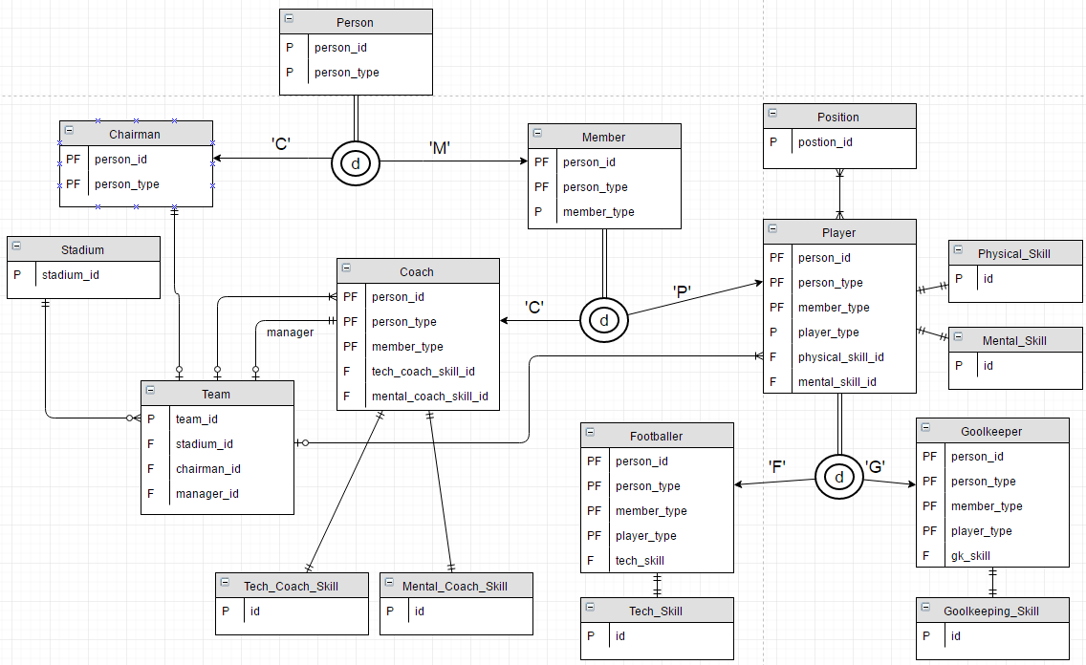

Logical Database

Person
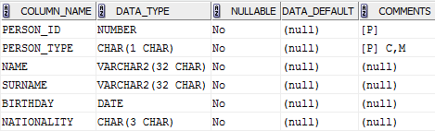

Chairman
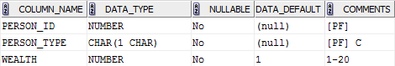

Member
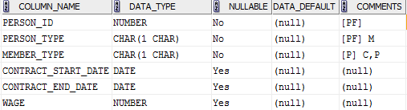

Coach
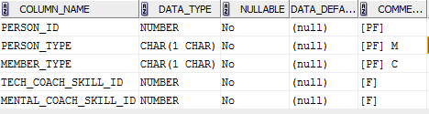

Player
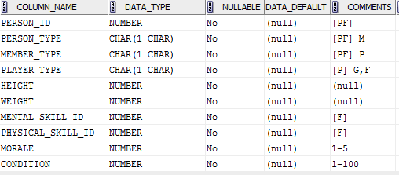

Goolkeeper
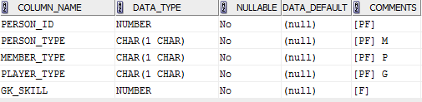

Footballer
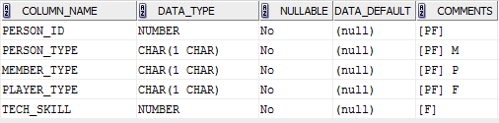

Tech_Coach_Skill
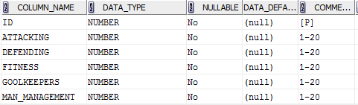

Mental_Coach_Skill
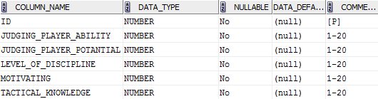

Physical_Skill
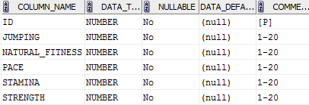

Mental_Skill
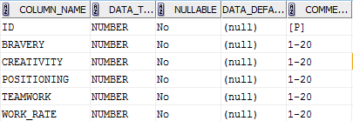

Goolkeeping_Skill
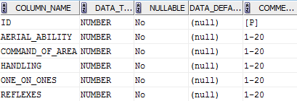

Tech_Skill
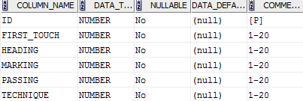

Stadium
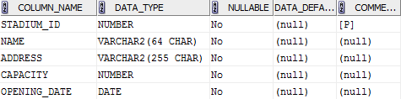

Team
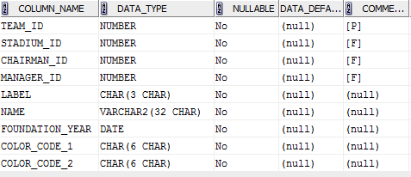

Team_To_Coach
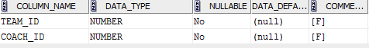

Team_To_Player
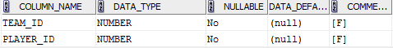

Position
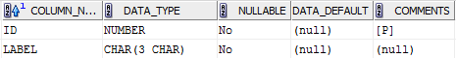

Player_To_Position
